**Visualisation**

**FSA Successful Prosecutions**

**FSA – Food Standards Agency**

The topic is based on the specifics of food hygiene/safety and animal welfare cases that have been registered and successfully initiated, as well as the fine amounts awarded and total cost.

1. **Line Plot**

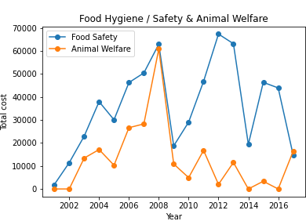

The above line plot depicts the graph, with the x-axis representing the year in which a specific case related to food safety and animal welfare was registered and the y-axis representing total expenditure for each case.

The blue plot depicts the expenditure data for food safety/hygiene cases while the orange plot depicts expenditure data for animal welfare.

The highest cost for a food hygiene case occurred in 2012 while the lowest occurred in 2001.

The highest cost for animal welfare case has occurred in 2008 with the lowest cost occurring in 2001, 2002, 2014, and 2016, indicating that the number of animal welfare cases is low every year compared to food hygiene.

Both cases were at an all-time high in 2008 and then dropped precipitously the following year.

1. **Bar Plot**

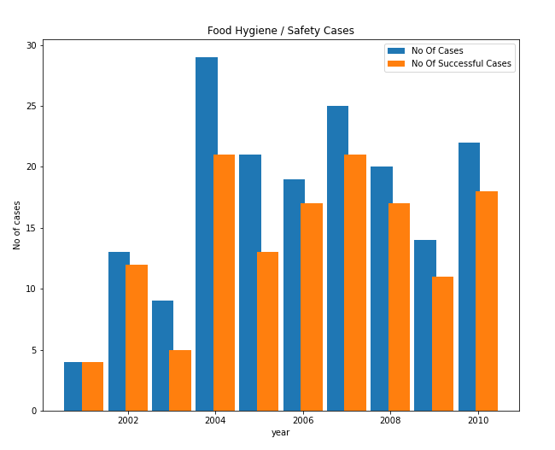

The above bar graph shows the number of cases commenced and the number of successful cases commenced throughout the course of the year.

It can be seen that in the year 2001 all the cases commenced have been successfully done.

In 2005, extremely few successful cases were started compared to the overall number of cases.

The number of food hygiene cases is lowest in 2001 that is 4 and the highest in 2004 that is 29, which is a drastic rise when compared with respect to other years. From the year 2003 to 2004 there has been a rapid rise in the cases.

There was a gradual decrease in the number of instances of both food hygiene and animal welfare from 2005 to 2009.

It is simpler to compare and display the data of the number of cases and the number of successful instances during each year using side-by-side bar graphs because the data is classified according to two criteria.

1. **Pie Chart**

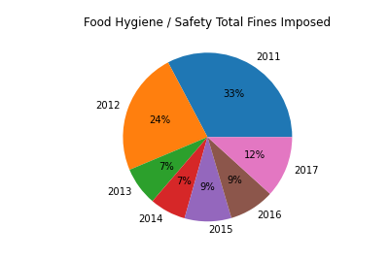

The above pie chart shows the total fines imposed for food hygiene/safety cases from the year 2011-2017.

The maximum fine issued is in the year 2011, and the minimum fine is split between two years, namely 2013 and 2014.

When compared to any previous year, the amount of fines levied from 2012 to 2013 fell dramatically, indicating that the number of instances must have decreased.

From the year 2011 to 2014 the fine imposed is significantly decreasing but from 2015 onwards it rises gradually but still there is no significant increase when compared to 2011.

I chose pie chart as one of the plots since it’s visually simple to understand the data than any other plot and also it accurately divides the data into correct proportions.

**Data Link:**

<https://www.data.gov.uk/dataset/17206153-70bf-4205-803e-93d30c0d2fc6/fsa-successful-prosecutions>

**Github Repository:**

<https://github.com/krishnajakk/visualisation-assignment>